**Chapter-1**

**INTRODUCTION**

This document will propose all features and procedures to develop the system. These documents specially containing details about objectives, scope, design model, primary requirements and finally monitoring and reporting mechanisms.

Evaluation has been an essential part of the education and is done through system of examinations. The students are to be evaluated against the subjects and topics covered over a period of time. Generally, the written examination is conducted for two to three hours and the work is to be evaluated as soon as possible. At college or institute level, a teacher is required to evaluate answer books of about 60 students per class. For proper evaluation, the examiner needs at least 15-20 minutes for each answer book. It means about 15-20 hours for each subject. Since we have only limited time available per day, the evaluation is spread over many days. When there are a large number of students to be examined, the evaluation requires considerable manual effort. In some cases, there are difficulties on account of poor handwriting. The task of evaluation is repetitive and boring. The quality of evaluation also varies in accordance with the mood of the examiner. In today’s environment if this could be automated, it would solve many of the above said problems. Hence, the solution lies in automating the work using computers.

Online Examination is being launched because a need for a destination that is beneficial for both Institutes and students. With this site, institutes can register and host online exams. Students can give exams and view their results. This site is an attempt to remove the existing flaws in the manual system of conducting exams. The project will enable educational institutes to conduct test and have automated checking of answers based on the response by the candidates.

**1.1 Background**

Online Examination System is a system that many educational institutions and all users of the system can benefit from it. Many institutions use various paper materials and pens to process the manual examination. But in this system, it provides the student information, questionnaires, and answers and automatically computes the scores. Itconducted through the website to remote candidates. Candidate is given a limited time to answer the questions and after the time expiry the answer paper is disabled automatically and answers is sent to the examiner. The examiner will evaluate answers, either through automated process or manually and the results will be sent to the candidate.

Today many organizations are conducting online examinations worldwide successfully and issue results online. There are advantages and disadvantages in online examinations. The advantage is that it can be conducted for remote candidates and evaluation of answers can be fully automated for multiple choice questions can be evaluated manually or through automated system, depending on the nature of the questions and the requirements. The disadvantage is there is no method to identify whether the exact students take that exam.

**Chapter-2**

**LITERATURE SURVEY**

Rashad et al. [2] propose an Arabic web-based exam management system that handles only objective questions. The objectives of developing web based exam are to conduct exams, collect answers, auto-grading and generate a report. A multitier architecture is used to develop the web-based exam. A survey is conducted to validate the system using a sample size of two hundred and fifty. The future work is to add more questions. The main limitations, of the system developed by Rashad et al. [2], are that it does not cover subjective questions, course learning outcomes, complexity and graphic questions like Data Flow Diagram (DFD) and Unified Modelling Language (UML). An ongoing research is presented by putting together a platform as a test bed for NGN application development [3- 4]. A novel component based development model is proposed to develop SIP based mobile applications. The proposed model used as a framework for general purpose application development over the test bed. The objectives of IP Multimedia System (IMS)-based mobile examination system approach is explained with reasons and advantages identified for objective questions. Main components of IMS service architecture with their roles are also described. The approach leads to a highly modular and extensible integrated system. IMS based application is considered to be the next generation mobile applications that enable developers to take advantage of mobile networks resources. IMS-based application is attributed with robustness and improved Quality of Experience (OoE) for mobile users.

Zhenming et al. [5] propose a novel web-based online objective examination system for computer science education. System transmits the answers into bit stream after encoding to ensure security and intrusion. It is password protected system and camera is there to monitor the activities of students. The web based examination is developed to handle basic computer skills. The system does not handle subjective exams and advanced computing courses. Therefore subjective skills of the students cannot be assessed using the system developed by Zhenming et al. [5].

Azim et al. [6] described the impact of online subjective assessment on the students as compared to objective assessments. The written ability of students is not checked while conducting the objective examination as per the results extracted by Azim et al. [6]. The study in [6] surveyed 100 private companies related to information technology field to collect the data of the candidates who got promotion after passing the OCP, MCSD or MCSE certifications. There were only few candidates who were promoted to senior positions because of written shortcoming. The subjective assessment system is the solution to check the writing skills of students [6].

A novel approach with subjective assessments for Examination system is introduced by Sinde and Chokhandre [7]. The web based system uses keywords to match with the answers. It is working like objective questions. A student will get marks if the keywords match otherwise if he/she will get zero if the order of keywords are changed or misspelled. The system does not allow students to write the answers of descriptive/subjective questions and it only deals with objective assessments. Aimin and Jipeng [8] describe the fundamentals to design and implement a web-based intelligent examination system. The main emphasis of web based intelligent examination system is to use degree of difficulty to select questions from the examination bank. Aimin and Jipeng [8] propose to develop an intelligent examination system for subjective evaluation.

Online tools that support managing of online assessments such as Moodle and Zoho are based on string matching technique for short answers but long answer evaluation is still handled manually by most systems [9],[10]. Features which are available currently in online assessment are [9], [10]:

• Question paper setting

• Online Evaluation of objective type questions

• Question bank editor

• Spell checker

• Grammar checker

• Report generation of result

• Descriptive answer evaluation is still an open problem. [6]

**2.1 Problem definition:**

In the traditional examination system there are a number of problems. It involves a tedious process with a lot of stationery and man power needed in conducting such examination [1]. In general any University or Board examination, the process requires all the examination centres to send a designated person from their centre to the University/Board examination office to collect the stationery required for conducting the examination in their centre. This stationery is allotted based on the candidates appearing for the examination from that centre. The stationery mainly involves the answer booklets / sheets where the candidates will answer their examinations question papers. These answer booklets / sheets need to be preserved securely and carefully so that they are not misplaced and misused. At the time to examination the room invigilator needs to carry these booklets / sheets to the examination block, distribute these booklets / sheets to the candidates, at the end of the examination collect them carefully and submit it to the examination section of that centre. The examination section of each centre packs these answer booklets / sheets of all the candidates, candidate wise and course wise and submits it to the University / Board examination office or the identified collection centres. This process involves a huge responsibility of the invigilators, examination section personnel and the University / Board personnel handling these answer booklets / sheets because they cannot afford to lose a single answer booklet / sheet. Another important and critical aspect of such examination is distribution of question papers to each of these centres. University / Board of examination identify experts to prepare question paper for each course of the examination. The University / Board select one question paper from a set of question papers prepared by the experts for every course. The selected paper is then printed and distributed to all the examination centres. This distribution process involves a panel of identified members to carry these question paper bundles to each centre and hand over the bundles to the examination centre authority. It is the responsibility of the examination centre authority to keep the question paper in a secure and concealed room till the date and specified time to open the bundle. The problems that arise here is the question paper may be stolen from the secured concealed room or the authority may by mistake open a wrong packet as there will be multiple question paper packets in his custody. To overcome these problems online examination systems were introduced. Such online examination system was for a long time limited to objective type or multi choice questions only. These examination systems were carried out online and sometimes the results were available immediately. Such examinations were not enough to measure the knowledge required by top level management status. It is important for candidates for candidates to express and analyse information in depth for handling high profile jobs. For these reasons it is must to have online examinations with subjective answers. Different techniques have been suggested for conducting subjective online examinations. One such system involves conducting the examination on a PC on a web browser. The candidates login to the server using a web browser and answer the examination using keyboard and mouse. With tablet PCs becoming popular, tablet based examination system were introduced. Here candidates use a tablet PC and stylus to answer the examination. Answering examination for a three hour duration using these techniques is a difficult task as it is tedious and time consuming to draw diagrams in such systems. So we are here proposing some devices that can be used in writing such examination which are more user friendly in usage.

## **2.2 Objective:**

General objective of our project is to change the current MCQ checking system into a descriptive one.This project would be very useful for educational institutes where regular evaluation of students’ is required.

**Chapter-3**

# REQUIREMENT GATHERING

* **Hardware & Software Requirements**

The following tables provide a summary of the hardware and software required to run the Server.

**3.1 Hardware requirements:**

The hardware requirements are sufficient for installing and running the application; however, for best results, expand the hardware requirements to optimize performance. The requirements can be expanded based on the size of your website and the number of users you will have..

|  |  |
| --- | --- |
| **HARDWARE** | **REQUIREMENTS** |
| **Processor** | Pentium Class PC (P4 - 3 GHz or greater; faster processor or multiple processors recommended) |
| **Memory** | 4 GB of RAM or more recommended |
| **Hard Disk** | * Approximately 800 MB * Approximately 10 GB of free space for scan logs on Agent Server * Approximately 200 GB of free space on the system hosting the database (equals approximately 400,000 pages) * Approximately 330 MB for the Web Services Explorer – GSC (Generic Service Client tool) version 8.1 used to test Web Services for security vulnerabilities |

* 1. **Software Requirements**

|  |  |
| --- | --- |
| **SOFTWARE** | **REQUIREMENTS** |
| **Operating System** | * Windows 2003 Server SP2 (32-bit or 64-bit)(also install .NET Framework 2.0 SP2) * Windows Server 2008 with Service Pack 2 (32-bit or 64-bit) * Windows Server 2008 R2 (64-bit) |
| **Supported Browsers** | * Microsoft Internet Explorer 6.0, 7.0, 8.0 * Mozilla Fire-Fox 3.0, 3.5, 3.6 * Google chrome |
| **Languages/**  **Software** | * Visual Studio 2005 * .Net Framework 2.0, * Visual Studio C# |

## 

## **3.3 Non-functional requirement**

**Performance:**

* After completing the exam, the entire score of the student will be calculated.
* The software shall support use of multiple users at a time.

**Usability:**

* The website should be user friendly and should require least effort to operate.

**Portability:**

* The website is made using HTML, CSS, ASP.NET which are platform independent and can be transported to other servers with minimum effort.

**Availability:**

* Students can take exam only during the previously allotted time slots, however can open site anytime to access other information.
* Colleges can register for the exam anytime.
* This system must run on multiple operating systems and support windows operating system

# 3.4 System Design Documentation

## **Introduction**

Design is the abstraction of a solution; it is the general description of the solution to a problem without a details. Design is view pattern seen in the analysis phase to be a pattern in a design phase. After design phase we can reduce the time required the implementation.

## **Purpose**

As stated in the [Requirements Analysis Document](http://dev.campuseventfinder.com/index.php?title=Requirements_Analysis_Document), the purpose of the system is to provide system administrator, colleges, departments and students with a central location for organizing various events. The purpose of this system provides the following reasons: No physical presence needed for examinations, No wastage of time during evaluation, Instant availability of the results, Starting and completion time are both recorded by the server, A series of online tests are offered by the software for the benefit of the students. In general the system is much more preferred due to these reasons across various organizations and the world.

## **Design goals**

The design goals represent the desired qualities of online examination system and provide a consistent set of criteria that must be considered when making design decisions. Based on non-functionality requirements the following design goals will have to achieve d in order to qualify the system as successful

**Robustness:** The system has to be robust enough to manage any valid input from the users.

**Reliability**:

* The system has to perform the online exam operations with no errors.
* The website developed should be extremely reliable and secure so that information about any questions etc. is not leaked before the actual exam is held.

**Security:** the system security is one of the most important non-functional requirements.

**Availability**:

* Students can take exam only during the previously allotted time slots, however can open site anytime to access other information.
* Colleges can register for the exam anytime.
* System should be able handle multiple users
* This system must run on multiple operating systems and support windows operating system.

### 

### **3.5 Hardware/Software Mapping**

Online exam system will be a web-based for online users. The system will run over the windows operating system. The web server will run over wampServer and the programming languages used for developing this system are: HTML, CSS, JS and PHP. We have selected MYSQL as the database management system. The online examination system consists of three independent components: Web browser, online System Server and database server. The following UML deployment diagram illustrates the hardware/software mapping for online examination system. 

**FIGURE: Hardware/Software mapping**

**Chapter-4**

**PLAN OF THE PROJECT**

**4.1 PLANING**

|  |  |  |  |  |
| --- | --- | --- | --- | --- |
| Number | Task | Activity | Timeline  Week no.  from the start  of the project | Resource Name |
| 1 | Requirements Specification | Complete specification of the system (with appropriate assumptions) A document detailing the same should be written and a presentation on that be made. | 2-3 | Attempt should be made to add some more relevant functionalities other than those that are listed in this document. |
| 2 | Technology familiarization | Understanding of the technology needed to implement the entire project. | 4-6 | The presentation should be from the point of view of being able to apply it to the project, rather than from a theoretical perspective. |
| 3 | High-level and Detailed Design | Listing down all possible scenarios (like application approval , rejection, cancellation, automatic redemption etc) and then coming up with flow-charts or pseudo code to handle the scenario. | 7-12 | The scenarios should map to the requirement specification (ie, for each requirement that is specified, a corresponding scenario should be there). |
| 4 | Implementation of the front-end of the system | Implementation of the main screen giving the created project specific domain name and the host for 24hr availability of the system, screen that follows the welcome page giving various options, screens for each of the options | 13-15 | During this milestone period, it would be a good idea for the team (or one person from the team) to start working on a test-plan for the entire system. This test-plan can be updated as and when new scenarios come to mind. |

|  |  |  |  |  |
| --- | --- | --- | --- | --- |
| 5 | Integrating the front-end with the database | The front-end developed in the earlier milestone will now be able to update the system Other features like geographic coordinate notification etc should be functional at this stage. In short, the system should be ready for integration testing. | 16-19 |  |
| 6 | Integration Testing | The system should be thoroughly tested by running all the test cases written for the system (from milestone 5). | 20-21 | Another 2 weeks should be there to handle any issues found during testing of the system. After that, the final demo can be arranged. |
| 7 | Final Review | Issues found during the previous milestone are fixed and the system is ready for the final review. | 22-24 | During the final review of the project, it should be checked that all the requirements specified during milestone number 1 are fulfilled (or appropriate reasons given for not fulfilling the same) |

**4.2 PROPOSED SYSTEM**

## **Functional requirements**

Required software is for conducting online examination and providing results. The system should satisfy the following requirements:

### **User Requirements**

* **Administrator Aspect**
  1. Taking back up of the database.
  2. Editing/Deleting/Creating the records.
  3. Adding faculty, department.
  4. Changing the super password.
* **Department Aspect**
  1. Logging into the system.
  2. Sending result to specific student.
  3. Accepting registrations of candidates.
  4. Adding/editing/deleting the questions.
  5. Issue Hall Ticket
  6. Set Exam Date
  7. Adding the candidate to a group.
  8. Creating questions.
  9. Posting questions.
  10. Posting multiple options to respective question.
  11. Marking correct answer within the given options.
  12. Time limit of the questions if any.
  13. Set marks.
* **Student Aspect:**
  1. Requesting registration.
  2. Logging into the system.
  3. Selecting the questions.
  4. Appearing for the examination.
  5. Reviewing the given responses.
  6. Changing password.
  7. Resetting of forgotten password
  8. Download Hall Ticket
  9. View Examination Timetable
* **Analysis**
  1. Authenticating users based on username and password
  2. Recording candidates’ responses to every question.
  3. Checking whether the given response is correct or not.
  4. Keeping history of mark reports of all users
  5. The reports are required to be sent to the candidates.
  6. Invitations/report for the appearance for the new test will be posted.

**4.3 SYSTEM ARCHITECTURE:**

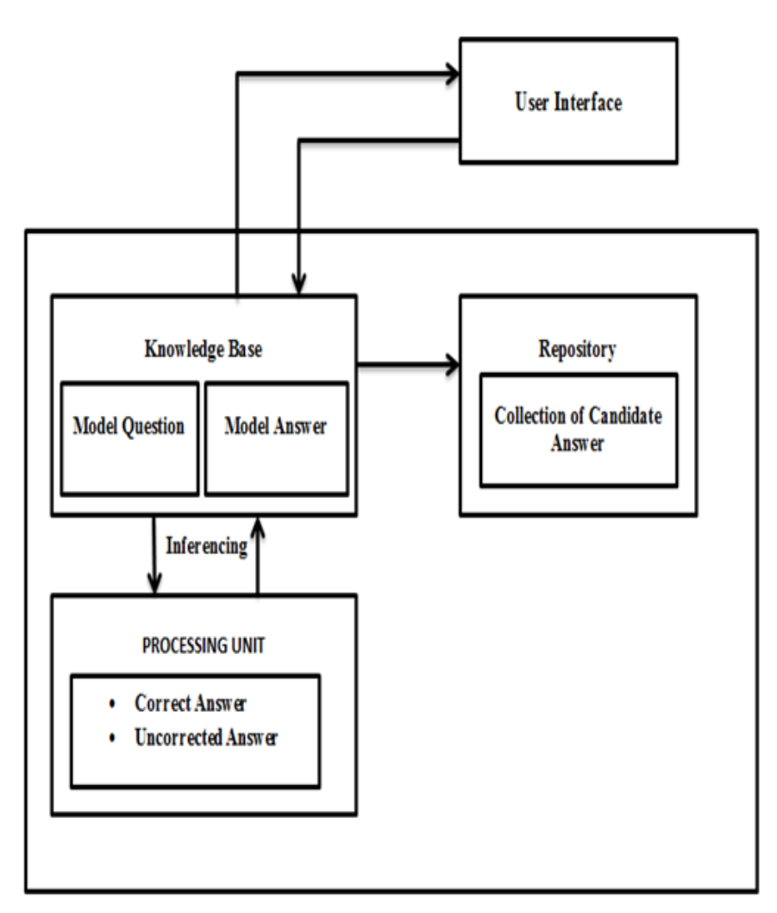

**4.4 FLOW CHART:**

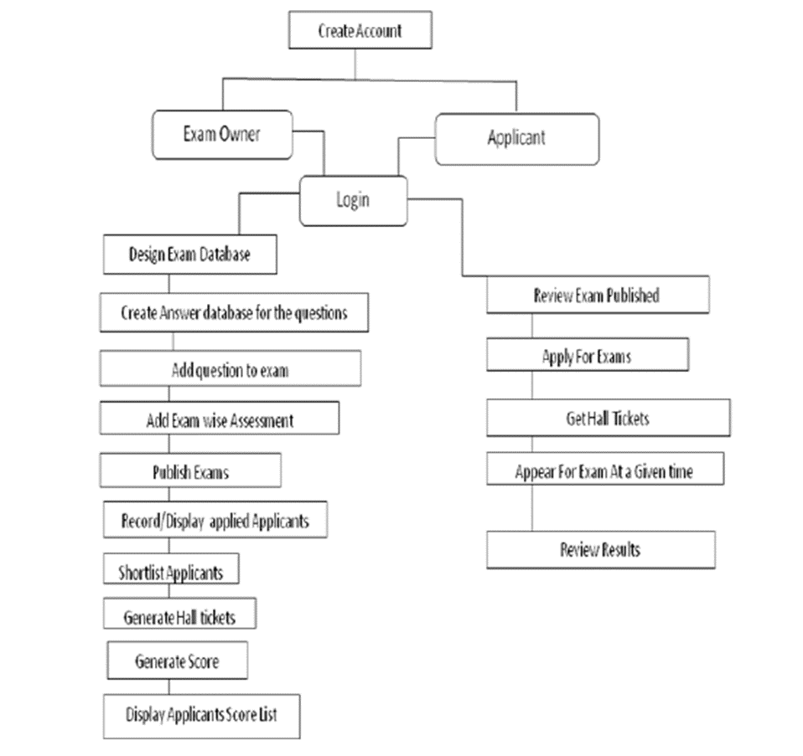

**PROCESS**

The inference process follows the following steps.

The first two steps are for the objective based question while steps three onwards are the process used to access the answers.

**Stage 1:** First the question style checked if it is yes / no format than the model answer related to those questions are called up for appropriate matching.

**Stage 2:** If it is one word answers then again the model answer are called up and a matching process is carried out. If its distance from the model answer is less than two we accept it as correct else the word is rejected an the answer is accessed as wrong.

**Stage 3:** One sentence based answer has to firstly check if they are in the same sequence [sequential form] as in the given model answer. Then we evaluate it as correct but for following case the process ignores if conjunctions or prepositions like ‘is’, ‘the’, ‘an’, ‘and’ if are missing are ignored and term the candidate answer as correct.

**Stage 4:** If the sentential form is different then we check for it synonym representation provided in our knowledge base system.

a. If sentential words used like “part” for “component or session” such cases are checked using wordnet dictionary if the appropriate meaning match’s than the answer is accepted else rejected.

b. The whole sentence, sentential meaning was checked with already stored in the database meaning termed to be right are considered else are left. Considering the model answer written in various form and these are written termed by ranking using the confidence factor provided by our system which was generated looking at the appropriate references like books articles for that answer used.

All the efforts are basically to reduce the complexity occurring during the representation of information. The collected information is then represented in an intermediate form, like first order predicate or conceptual dependency for removing complexity for further processing.

**4.5 GANTT CHART**

A Gantt chart is a type of bar chart, devised by Henry Gantt that illustrates a project schedule. Gantt chart illustrates the start and finish dates of the terminal elements and summary elements of a project. Terminal element and summary element comprises of the work breakdown structure of project.

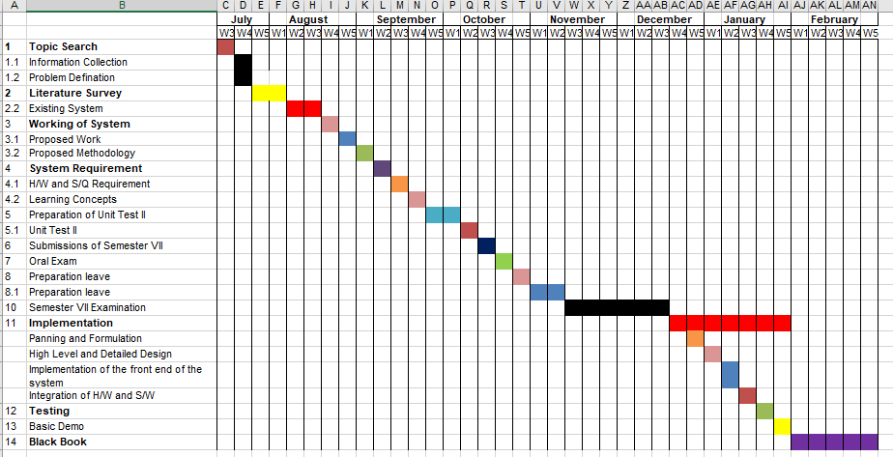

**Chapter-5**

**PROJECT ANALYSIS**

**5.1 Use Case Diagram**

A use case diagram at its simplest is a representation of a user's interaction with the system and depicting the specifications of a usecase. A usecase diagram can portray the different types of users of a system and the various ways that they interact with the system. This type of diagram is typically used in conjunction with the textual use case and will often be accompanied by other types of diagrams as well. 

**Figure 5.1:Use Case Diagram**

**5.1.2 Use Case Analysis**

Use case analysis is a technique used to identify the requirements of a system (normally associated with software/process design) and the information used to both define processes used and classes (which are a collection of actors and processes) which will be used both in the use case diagram and the overall use case in the development or redesign of a software system or program. The use case analysis is the foundation upon which the system will be built.

**5.2 Sequence Diagram:**

Sequence diagram displays the time sequence of the objects participating in the interaction. Sequence diagram are used to visualize and explore the interaction between the users, screensand the object instances within the system. They provide an ordered sequential map of messages passing between objects over time. The sequence diagram is typically represented by a horizontally deployed set of the actors and object instances, each having a verified life span bar. Messages are drawn from one object to another with an arrow indicating the direction of flow.

The sequence diagram will show how the flow or the actor will perform the task in the given system.

**Sequence Diagram Student:**

**Sequence Diagram Department:**



**Sequence Diagram Admin:**



**5.3 Collaboration Diagram:**

A collaboration diagram, also called a communication diagram or interaction diagram, is an illustration of the relationships and interactions among [software](http://searchsoa.techtarget.com/definition/software) [object](http://searchsoa.techtarget.com/definition/object)s in the Unified Modeling Language (UML). The concept is more than a decade old although it has been refined as modeling paradigms have evolved.

**Collaboration Diagram Student:**



**Collaboration Diagram Department:**



**Collaboration Diagram Admin:**



**5.4 ACTIVITY DAIGRAM**

An activity diagram shows the flow from activity to activity. And is an ongoing non atomic execution within a state machine. Activities ultimately result in some action, which is made up of executable atomic computations that result in a change in state of the system or the return of a value. Actions encompass scaling another operation, sending a signal, creating or destroying an object, or some pure computation, such as evaluating an expression. Graphically, an activity diagram is a collection of vertices and arcs.



**Figure. 5.2: Activity Diagram Student**



**Figure: Activity Diagram Department**

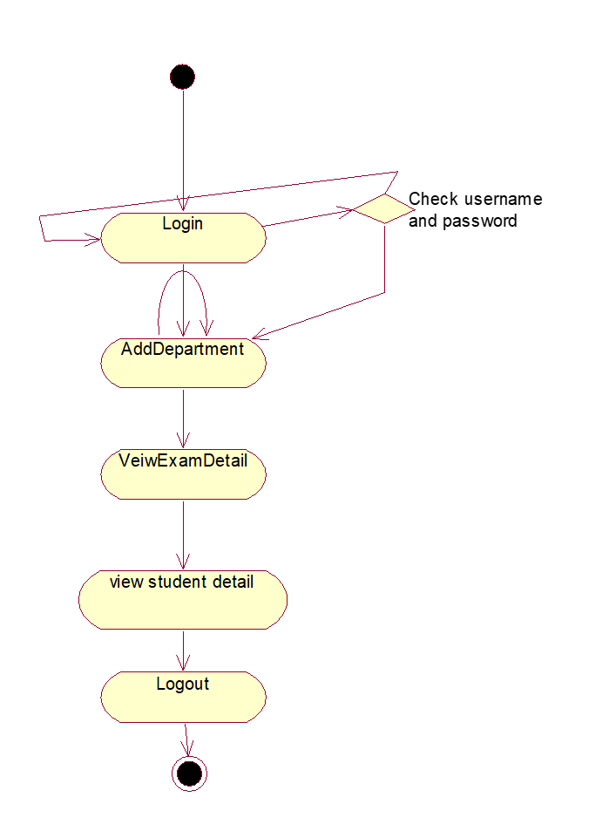

**Figure: Activity Daigram Admin**

**Chapter-6**

**PROJECT DESIGN**

**6.1 Design Model**

Software design is the process by which an agent creates a specification of a software artifact, intended to accomplish goals, using a set of primitive components and subject to constraints. Software design may refer to either "all the activity involved in conceptualizing, framing, implementing, commissioning, and ultimately modifying complex systems" or "the activity following requirements specification and before programming, as a stylized software engineering process.

**6.1.2 Data Flow Diagram**

A Data Flow Diagram (DFD) is a graphical representation of a flow of data through an information system, modelling its process aspects. A overview of the system which can later be elaborated. A DFD shows what kind of information will be input to and output from the system, where the data will come from and go to, and where the data will be stored. It does not show information about the timing of process or information about whether processes will operate in sequence or in parallel.

Data flow diagrams are also known as bubble charts. DFD is a designing tool used in the top-down approach to Systems Design. This context-level DFD is next "exploded", to produce a Level 1 DFD that shows some of the detail of the system being modelled. The Level 1 DFD shows how the system is divided into sub-systems (processes), each of which deals with one or more of the data flows to or from an external agent, and which together provide all of the functionality of the system as a whole. A level 2 data flow diagram (DFD) offers a more detailed look at the processes that make up an information system than a level 1 DFD does. It can be used to plan or record the specific makeup of a system.

**Level 0**

APPLICATION

USER

**Figure 6.1.2(a) - Level 0 DFD**

**Level 1**

APPLICATION

User

**Figure 6.1.2( b) - Level 1 DFD**

**Level 2**

APPLICATION

Department

**Figure: 6.1.2© Level 2 DFD**

**6.2 Class Diagram:**

Class Daigram is a type of static structure diagram that describes the structure of a system by showing the system's [classes](https://en.wikipedia.org/wiki/Class_(computer_science)), their attributes, operations (or methods), and the relationships among objects.

The class diagram is the main building block of [object-oriented](https://en.wikipedia.org/wiki/Object-oriented_programming) modelling. It is used for general [conceptual modelling](https://en.wikipedia.org/wiki/Conceptual_model) of the systematic of the application, and for detailed modelling translating the models into [programming code](https://en.wikipedia.org/wiki/Programming_code). Class diagrams can also be used for [data modeling](https://en.wikipedia.org/wiki/Data_modeling). The classes in a class diagram represent both the main elements, interactions in the application, and the classes to be programmed.



**Chapter-7**

**IMPLEMENTED SYSTEM**

# 7.1 Implementation

**a. Mode of Conducting Examination**

Question paper is prepared by the subject teacher in consultation with the technical staff conversant with the project who assist in uploading the same in the desired format. The current version of the system caters for five questions per test. You may design as many tests as you need. Students appear for the test online within the lab. User authentication has been incorporated. On successful login, each student gets the question paper and his/her blank answer book. They are required to answer the questions by typing in the space provided. The software facilitates saving of the typed work as per user convenience. In case of a system failure, the saved work is available to the student for continuation. After the specified time the students are required to save their work and logout.

**b. Computing Results**

Results are computed on the click of a button. The software also facilitates manual viewing of the answers for each question for all the students as well as full answer book of a single student. For keeping hard copy of the written work, printing of all answer books has also been provided. In case the results are found at variance from the expected ones, the software can also be trained to adapt to the new changes.

**Software Part**

**7.2 Results (Screen shots)**

1. Refer the figure given below it shows the login page for the authenticated Teacher,admin and the students

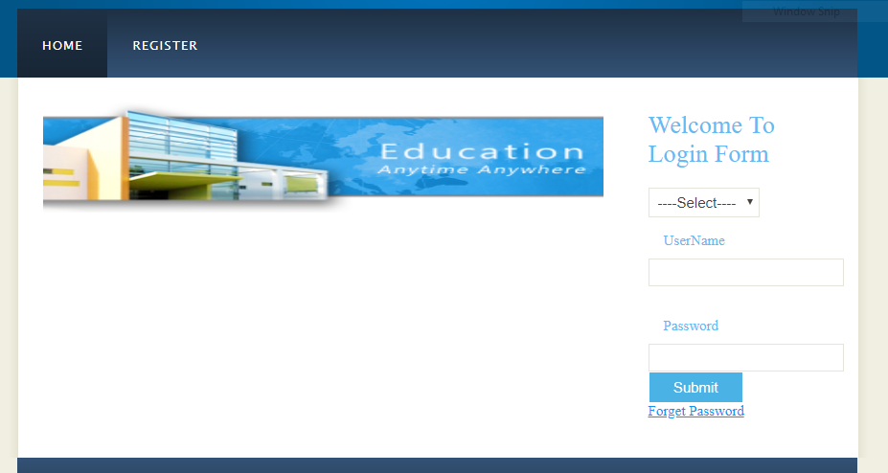

**Fig.:-7.1 Login Page**

1. Suppose new user want to register to the app it will be displayed as shown in figure 7.2

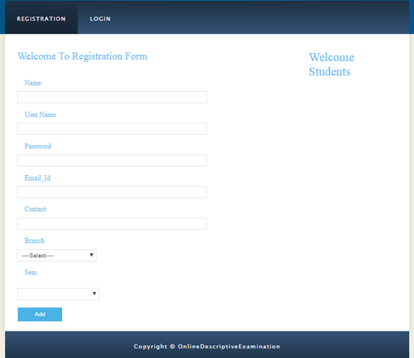

**Fig:- 7.2 New user Registration**

1. Here student can give their test and get the result.

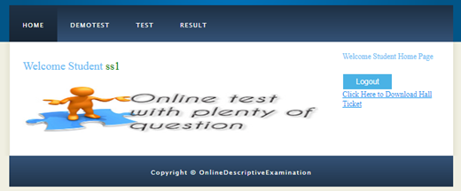

**Fig:- 7.3 Student Home Page**

1. Admin can add teacher,check student list and teacher list,provide exam date and hall ticket.



**Fig:7.4(a) Admin Home Page**

1. The snap shows the list of teachers and their respective branches which are added by the Admin.

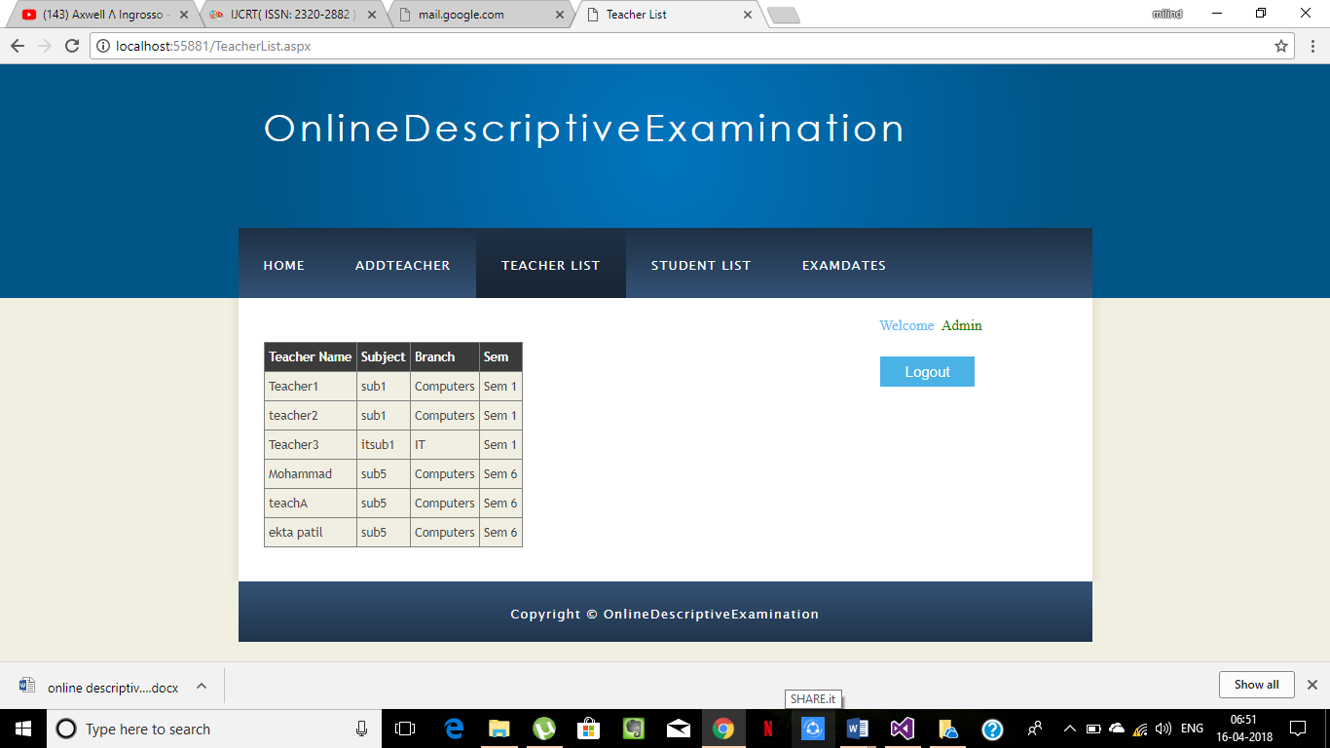

**Fig:7.4(b) Admin Home Page**

1. Similarly, we can get student list by selecting branch and semester

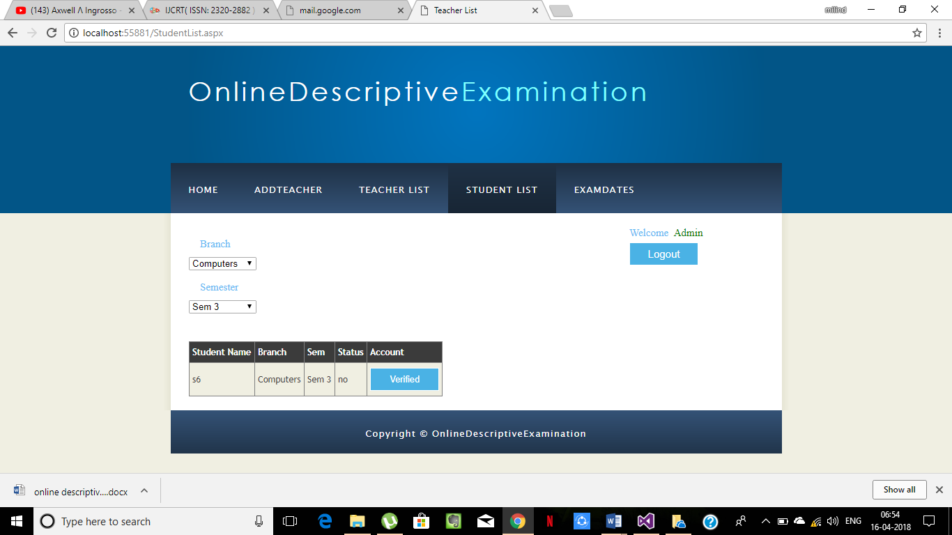

**Fig:7.4(c) Admin Home Page**

1. The admin will set exam dates which will generate hall ticket

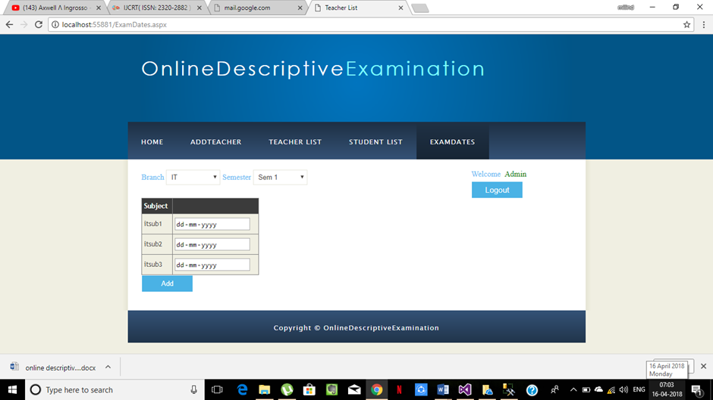

**Fig:7.4(d) Admin Home Page**

1. Teacher login and adds questions

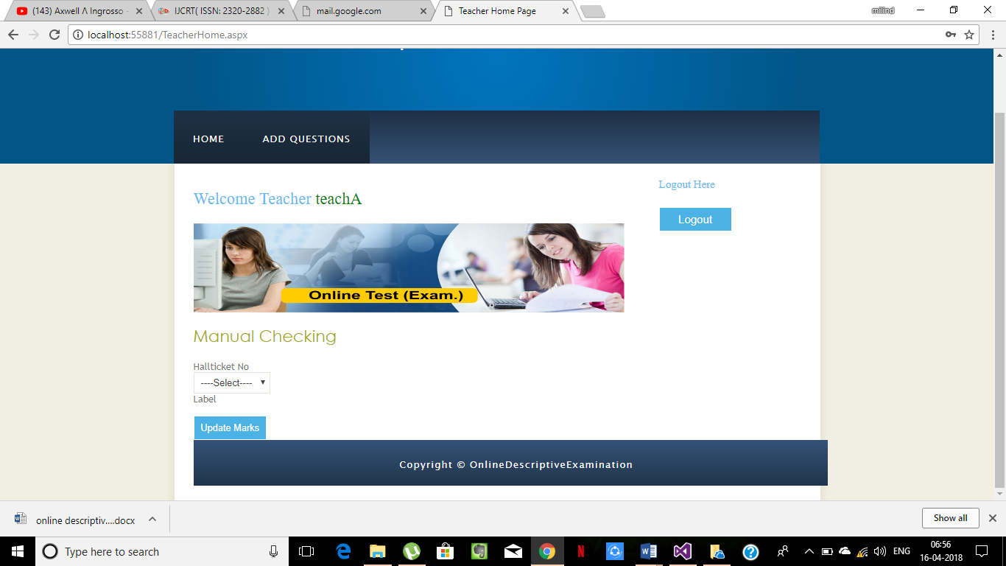

**Fig:7.5 Teacher Home Page**

**7.3 Code Snap (screen shots)**

* A Demo C# Code For Admin Page.

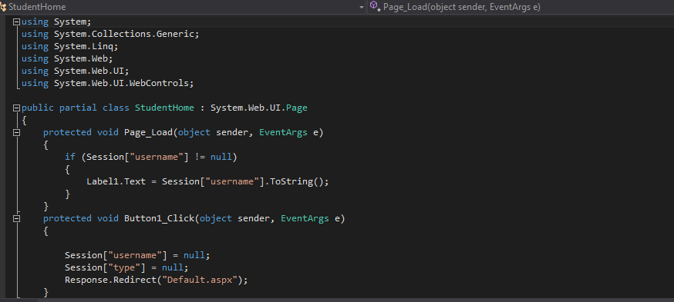

* Web.Configuration Code

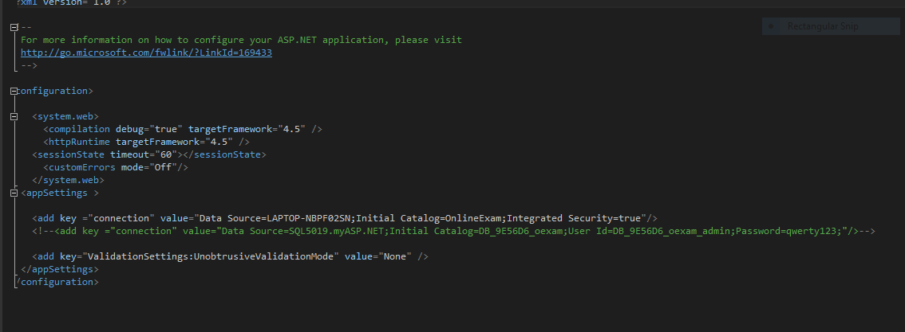

**Conclusion and Future Scope**

**9.1 Conclusion**

In traditional examination system there is a lot human effort required along with stationery needed for conducting the examination system. Even if one candidate is going to answer the examination a set of people responsible for conducting the examination are required to do all the formalities. With the proposed system, candidates can answer their examination on digital answer paper and submit the digital answer paper to the server directly from where it can be accessed for human evaluation system or automatic evaluation system. This process will reduce the tedious job of the examination boards, examination canter’s and the invigilators. Automatic evaluation can further be help in reducing the task of the evaluators and also facilitate a fair evaluation system. This project has tremendous potential for implementation at large scale. With subsequent research, the system may be adopted by all organisations as well as at university level. It would save enormous amount of man hours for evaluation of examinations. It would also save time, effort and paper and help to overcome other limitations of manual evaluation.

**9.2 Future Scope**

* Lot of Machine Learning and Artificial intelligence.
* With machine learning emerging will give strong background and help evaluation of answer by great scope and give the machine the ability to evaluate descriptive answers in justice way.
* Now a days every thing is happening online so there is a big scope of exam system to be online.

**REFERENCES**

# [1] Aakash Trivedi, "A relevant online examination system," t4e, pp.32-35, 2010 International Conference on Technology for Education, 2010

# [2] Huiping Wang, Ruowu Zhong, "Design and Implementation of Online Exam System Based on Data Mining," icicis, pp.207-209, 2011 International Conference on Internet Computing and Information Services, 2011

# [3] Xiaojun Guo; Chanle Wu; Yibo Chen; Ming Xie, "Interactive Items-Based Online Examination System," *Internet Technology and Applications (iTAP), 2011 International Conference on*, vol., no., pp.1,4, 16-18 Aug. 2011 doi: 10.1109/ITAP.2011.6006430 URL:http://ieeexplore.ieee.org/stamp/stamp.jsp?tp=&arnumber=6006430&isnumber=6006106

# [4] Göhner, Peter and Jeschke, Sabina and Natho, Nicole and Pfeiffer, Olivier (2007) *Design and Implementation of Hybrid Examinations for the Academic Education using Tablet PCs.* In: Proceedings of the 4th IEEE GCC

**ACKNOWLEGDEMENT**

No project is ever complete without the guidance of those expert who have already traded this past before and hence become master of it and as a result, our leader. So we would like to take this opportunity to take all those individuals how have helped us in visualizing this project.

We express our deep gratitude to our principal **Dr. Chelpa Lingam** and project guide **Dr. Anitha Patil** for providing timely assistant to our query and guidance that he gave owing to his experience in this field for past many years. He had indeed been a lighthouse for us in this journey.

We would also take this opportunity to thank our project co-coordinator **Prof. Srijita Bhattacharjee** for her guidance in selecting this project and also for providing us all this details on proper presentation of this project.

We extend our sincerity appreciation to all our Professors from **MES Pillai’s HOC College of Engineering and Technology** for their valuable inside and tip during the designing of the project. Their contributions have been valuable in so many ways that we find it difficult to acknowledge of them individual.

We also grateful to our **H.O.D. Dr. Ashok Kanthe** for extending his help directly and indirectly through various channels in our project work.

Thanking You

Saurabh Singh

Shlok Nakti

Milind Jamkhandi

**AUTHOR’S PUBLICATION**

Saurabh Singh, Shlok Nakti, Milind Jamkhandi. ”Online Subjective or Descriptive Examination”,  INTERNATIONAL JOURNAL OF CREATIVE RESEARCH THOUGHTS (IJCRT), Impact Factor: 5.97, April 2018, Volume 6, Issue 2, ISSN:2320-2882.